AUTHOR

|  |  |  |  |  |  |  |
| --- | --- | --- | --- | --- | --- | --- |
| **Department** |  | **Signature** |  | **Print Name** |  | **Date** |
| R&D |  |  |  | Manny Jasus |  |  |

SIGNATURES

|  |  |  |  |  |  |  |
| --- | --- | --- | --- | --- | --- | --- |
| **Department** |  | **Signature** |  | **Print Name** |  | **Date** |
| R&D |  |  |  | Douglas Tenney |  |  |
|  |  |  |  |  |  |  |
| **Department** |  | **Signature** |  | **Print Name** |  | **Date** |
| R&D |  |  |  | Kenneth Woodland |  |  |
|  |  |  |  |  |  |  |
| **Department** |  | **Signature** |  | **Print Name** |  | **Date** |
| QA |  |  |  | Barbara Haglind |  |  |

Revision History

|  |  |  |  |  |  |  |  |
| --- | --- | --- | --- | --- | --- | --- | --- |
| **Rev.** |  | **Date** |  |  | **Initials** |  | **Description** |
| 0.1 |  | 13-MAY-2019 |  |  | MAJ |  | Created |
| 0.2 |  | 15-MAY-2019 |  |  | MAJ |  | Updates after review and execution |
| 0.3 |  | 10-JUL-2019 |  |  | MAJ |  | Updates after review and execution |
| 0.4 |  | 12-JUL-2019 |  |  | MAJ |  | Updates after review |
| A |  | 12-JUL-2019 |  |  | MAJ |  | Change Revision |

Glossary

PC – Personal Computer

SN – Serial Number

References

|  |  |
| --- | --- |
| **Number** | **Title** |
| 1420006 | Design Controls Procedure |
| 1400019 | Document Control System |
| 1400027 | Obsolescence/Deletion of Controlled Documentation |
| 1400032 | Standards for Controlled Documentation |
| 1400141 | Risk Management |
| 1400160 | Technical Review Process |
| 1400158 | Software Issue Classification Procedure |
| 1400021 | Supplier Qualification Procedure |
| 14000068 | Manufacturing Software Realization Process |
| 14000095 | Engineering Change ECR Process |
| 14000184 | Software Validation Process |
| 1400004 | Procedure, Software Level of Concern Analysis |
| 14000031 | User Needs and Design Input Requirement |
| 14000190 | Usability Engineering |
| 14000208 | UDI Direct Part Marking |
| BS EN 62304 | Medical device software – Software life cycle processes |
| BS EN 62366-1 | Medical devices – Application of usability engineering to medical devices |
| BS EN ISO 14971 | Medical devices – Application of risk management to medical devices |
| CPO-RA-009 | Unique Device Identifier (UDI) Policy (Note: relevant only for software delivered as stand-alone medical device). |

Table of Contents

1 INTRODUCTION 5

2 PURPOSE/SCOPE 5

3 TEST MATERIAL / TOOLS AND EQUIPMENT 5

4 REQUIREMENTS 6

5 TEST METHOD / STUDY DESIGN 6

5.1 Installation Qualification 6

5.2 Operational Qualification 6

6 TEST CASES 7

6.1 Setup - Install the EZ-Tap Pro hardware. 8

6.2 Install the EZView application software 8

6.3 Identification 10

6.4 EZView Toolbar Options - Capture and view data as text 11

6.5 EZView Toolbar Options - Communications Settings 13

6.6 EZView Toolbar Options – Program Options Settings 14

6.7 EZView Toolbar Options – Capture Columns Settings 16

6.8 EZView Toolbar Options – Display Mode Settings 17

6.9 EZView Toolbar Options – View Settings 18

7 REQUIREMENTS TRACEABILITY 20

8 ACCEPTANCE CRITERIA 21

9 FIGURES 21

9.1 Installation of the EZ-Tap Pro hardware 21

9.2 The EZView icon is displayed on the Desktop 21

9.3 EZView comes up in New Capture mode 22

9.4 On the EZView New Capture Mode screen, click Help > About EZView 22

9.5 EZView Toolbar Options - Capture and view data as text 23

9.5.1 Highlighting a Single Line of Data 23

9.5.2 Highlighting Multiple Lines of Data 23

9.6 Save EZView Data as Text 25

9.7 EZView Toolbar Options - Communications Settings 25

9.8 EZView Toolbar Options – Program Options Settings) 27

9.9 EZView Toolbar Options – Capture Columns Settings 28

9.10 EZView Toolbar Options – Display Mode Settings 29

9.10.1 Single Byte Mode 29

9.10.2 Line Mode 29

9.11 Viewing Captured EZView Data 29

10 Attachments 30

10.1 Attached Data file EZView Data_01.txt 30

10.2 Attached Data file EZView Data_02.txt 30

# INTRODUCTION

This document presents Validation Tests for the EZ-TAP Pro data sniffer tool for use in monitoring an RS232 interface at a baud rate up to 115200.

# PURPOSE/SCOPE

Purpose: This document identifies the principal features of the EZ-Tap Pro data sniffer tool that are used to support testing of RS232 interfaces at a baud rate up to 115200. An example of which is the RS232 interface between the DYONICS POWER II and INTELLIO Link products.

Scope: This document presents test cases required to verify specific actions as valid uses of this tool, per the requirements specified in Section 4.

# TEST MATERIAL / TOOLS AND EQUIPMENT

These tests were conducted with the following materials:

|  |
| --- |
| 1. DYONICS POWER II Control System |
| 1. INTELLIO Link |
| 1. Windows PC |
| 1. EZ-Tap Pro with EZView |

# REQUIREMENTS

The requirements for the EZ-Tap Pro and EZView are listed below.

| **Req ID** | **Software Requirement Specifications** |
| --- | --- |
| REQ 001 | The user shall be able to install the EZView software. |
| REQ 002 | The user shall be able to start up EZView and connect to the EZ-Tap Pro. |
| REQ 003 | The user shall be able to display identifying information about EZ-Tap Pro and EZView. |
| REQ 004 | The user shall be able to capture serial data from the EZ-Tap Pro using the EZView application. |
| REQ 005 | The user shall be able to save EZView data. |
| REQ 006 | The user shall be able to specify communications settings. |
| REQ 007 | The user shall be able to specify program options settings. |
| REQ 008 | The user shall be able to specify capture columns settings. |
| REQ 009 | The user shall be able to specify display mode settings. |
| REQ 010 | The user shall be able to specify view settings. |
| REQ 011 | The user shall be able to view captured EZView data. |

# TEST METHOD / STUDY DESIGN

## Installation Qualification

The EZ-Tap Pro device version 26, with EZView software version 1.6.7, installed on Windows 10.

## Operational Qualification

The EZ-Tap Pro device with EZView software has the specified required features.

# TEST CASES

|  |  |  |  |  |  |  |  |  |  |
| --- | --- | --- | --- | --- | --- | --- | --- | --- | --- |
|  | TESTER & TEST CASE REVIEW SECTION | | | | | | | |  |
| SUCCESSFUL TEST: | | | PASS [ ] | | | FAIL [ ] | | | |
| Tested by: | | | | Date Tested: | Signature: | | | | |
| Reviewed by: | | | | Date Reviewed: | Signature: | | | | |
|  | TEST INFORMATION SECTION | | | | | | | |  |
| Purpose: | | To verify the requirements for the EZ-Tap Pro and EZView as specified in section 4 and traceability as specified in section 7. | | | | | | | |
|  | TEST EQUIPMENT & SUPPLIES SECTION | | | | | | | |  |
| EQUIPMENT NEEDED: (Include where applicable Qty., PN, Rev., and Description) | | | | | Serial Number | | Calibration ID | Version number | |
| 1. DYONICS POWER II Control System | | | | |  | | N/A |  | |
| 1. INTELLIO Link | | | | |  | | N/A |  | |
| 1. EZ-Tap Pro with EZView | | | | |  | | N/A |  | |
| 1. Windows PC with Windows operating system | | | | |  | | N/A |  | |

## Setup - Install the EZ-Tap Pro hardware.

This is a precondition to testing. The EZ-Tap Pro device is intended for use on an RS-232 serial data line between the DYONICS POWER II Control System and the INTELLIO Link. The EZ-Tap Pro device is connected as shown in Fig. 9.1.

## Install the EZView application software

| **Step** | **Test Actions** | **Expected Result** | **Actual Result** | **Status** |
| --- | --- | --- | --- | --- |
| 1. 0 | Precondition: Equipment items 1-4 are in place. | Precondition is satisfied. |  | [ ] Done |
|  | Using the directions supplied by the manufacturer, install the EZView application software on a PC running a Microsoft Windows operating system. | The EZView icon is displayed on the Desktop, as shown in Figure 9.2. (REQ 001) |  | [ ] Done |
|  | Disconnect EZ-Tap Pro USB connector from the PC. Press the EZView icon on the desktop. | **Verify** the EZView runs and reports the EZ-Tap not found (REQ 001) |  | [ ] Pass  [ ] Fail |
|  | Press No button on the EZView error dialog box | **T**he EZView screen is displayed. |  | [ ] Done |
|  | Select File > Exit on EZView window to exit the application.  Connect the EZ-Tap Pro USB connector to the PC. | EZ-Tap Pro hardware and EZView software are properly installed and connected. |  | [ ] Done |
|  | Click the EZView icon on the PC Desktop. | **Verify** the EZView comes up in New Capture mode, as shown in Figure 9.3. No errors are reported. (REQ 002) |  | [ ] Pass  [ ] Fail |

## Identification

| **Step** | **Test Actions** | **Expected Result** | **Actual Result** | **Status** |
| --- | --- | --- | --- | --- |
| 1. 0 | Precondition: Equipment items 1-4 are in place. | Precondition is satisfied. |  | [ ] Done |
|  | On the EZView New Capture Mode screen, click Help > About EZView.  Record EZ-Tap Pro version information, as shown in Figure 9.4. | The About EZView window is displayed. | EZView version: _____________  EZ-Tap Pro FW version: _______ | [ ] Done |
|  | Compare the identifying information recorded above with the software packaging. | **Verify** the EZView application installed matches the expected version and product information. (REQ 003) |  | [ ] Pass  [ ] Fail |
|  | Click the OK button to close the About EZView window and return to New Capture Mode. | User is returned to the New Capture Mode screen |  | [ ] Done |

## EZView Toolbar Options - Capture and view data as text

| **Step** | **Test Actions** | **Expected Result** | **Actual Result** | **Status** |
| --- | --- | --- | --- | --- |
| 1. 0 | Precondition: Equipment items 1-4 are in place. | Precondition is satisfied. |  | [ ] Done |
|  | If not already running, power on the DYONICS POWER II.  If not already running, press the EZView icon on the Desktop to start EZView. | EZView starts up and displays the New Capture Mode screen |  | [ ] Done |
|  | On the EZView screen press the green button  located on the toolbar. | The New Capture Mode screen is displayed, showing captured data scrolling. |  | [ ] Done |
|  | On the EZView screen press the red square  to stop the capturing | Data exchanged between the DYONICS POWER II and the INTELLIO Link is displayed on the EZView screen. |  | [ ] Done |
|  | The screen may be scrolled up or down. A data line may be highlighted by clicking on it. An example of a selected line is shown in Figure 9.5.1, excerpted from file EZView Data_01.txt in Attachments. | The data line is highlighted. |  | [ ] Done |
|  | Multiple lines may be highlighted by holding the Ctrl key down while clicking the lines. An example of a selected line is shown in Figure 9.5.2, excerpted from file EZView Data_01.txt in Attachments. | The data lines are highlighted. |  | [ ] Done |
|  | In the dropdown menu click “Save Data as Text…” | The Save As window opens. |  | [ ] Done |
|  | Select a folder location and a file name for the new text file.  Record the filename.  The “.txt” extension is added automatically.  Click the Save button. | The Text File Options window opens.  See Figure 9.6.  The filename is recorded.  The captured data is saved. | Filename: __________________ | [ ] Done |
|  | Open the captured data file and review the contents. | **Verify** the captured data contains the expected data. (REQ 004, REQ 005, REQ 011) |  | [ ] Pass  [ ] Fail |

## EZView Toolbar Options - Communications Settings

| **Step** | **Test Actions** | **Expected Result** | **Actual Result** | **Status** |
| --- | --- | --- | --- | --- |
| 1. 0 | Precondition: Equipment items 1-4 are in place. | Precondition is satisfied. |  | [ ] Done |
|  | On the EZView New Capture Mode screen, click Settings > Communications | The Communications settings window opens. |  | [ ] Done |
|  | Set for 115200 bps, 8 data bits, No parity, 1 stop bit, signaling level RS232/TTL.  No other settings. Once set, these settings are not changed. An example of these settings is shown in Figure 9.7. Click the OK button. | User is returned to the New Capture Mode screen.. |  | [ ] Done |
|  | Open the Communications settings window and compare the settings to those made in the previous step. After comparison, click the OK button. | **Verify** the communications window settings were retained. (REQ 006) |  | [ ] Pass  [ ] Fail |

## EZView Toolbar Options – Program Options Settings

| **Step** | **Test Actions** | **Expected Result** | **Actual Result** | **Status** |
| --- | --- | --- | --- | --- |
| 1. 0 | Precondition: Equipment items 1-4 are in place. | Precondition is satisfied. |  | [ ] Done |
|  | On the EZView New Capture Mode screen, click Settings > Program Options | The Program Options window is displayed |  | [ ] Done |
|  | Set for Buffer size 10000000, check on Show ASCII codes, enter Font size 32, check on Absolute Time. Check on Spool Captured data to a File, and click the Character mode radio button. No other settings are required. Click the OK button. Once set, these settings are not changed. An example of these settings is shown in Figure 9.8. | The Program Options Settings are displayed. | Buffer size: __________________  Show ASCII codes: ___________  Absolute Time: _______________  Character Mode: _____________ | [ ] Done |
|  | Click the OK button. | User is returned to the New Capture Mode screen |  | [ ] Done |
| 1. Open the | Open the Settings > Program Options window.  Compare the settings to those set above.  Click the OK button. | **Verify** the settings match those set above. (REQ 007) |  | [ ] Pass  [ ] Fail |

## EZView Toolbar Options – Capture Columns Settings

| **Step** | **Test Actions** | **Expected Result** | **Actual Result** | **Status** |
| --- | --- | --- | --- | --- |
| 1. 0 | Precondition: Equipment items 1-4 are in place. | Precondition is satisfied. |  | [ ] Done |
|  | On the EZView New Capture Mode screen, click Settings > Capture Columns. An example of these settings is shown in Figure 9.9 | The Column Selection window is displayed. |  | [ ] Done |
|  | Check on Line #, Time, DTE (hex), and DCE (hex). No other settings. Once set, these settings are not changed. |  | Line #:_________________  Time: _________________  DTE (hex): _____________  DCE (hex): _____________ | [ ] Done |
|  | Click the OK button. | User is returned to the New Capture Mode screen |  | [ ] Done |
|  | On the EZView New Capture Mode screen, click Settings > Capture Columns. | **Verify** the Settings>Capture Columns settings match those made above. (REQ 008) |  | [ ] Pass  [ ] Fail |

## EZView Toolbar Options – Display Mode Settings

| **Step** | **Test Actions** | **Expected Result** | **Actual Result** | **Status** |
| --- | --- | --- | --- | --- |
| 1. 0 | Precondition: Equipment items 1-4 are in place. | Precondition is satisfied. |  | [ ] Done |
|  | Two Display Modes are used, Single Byte Mode and Line Mode.  For Single Byte Mode:  On the EZView New Capture Mode screen, click Settings > Display Mode > Single Byte Mode. An example is shown in Figure 9.10.1. | **Verify** data is displayed in Single Byte Mode. (REQ 009) |  | [ ] Pass  [ ] Fail |
|  | For Line Mode:  On the EZView New Capture Mode screen, click Settings > Display Mode > Line Mode. An example is shown in Figure 9.10.2. | **Verify** data is displayed in Line Mode. (REQ 009) |  | [ ] Pass  [ ] Fail |

## EZView Toolbar Options – View Settings

| **Step** | **Test Actions** | **Expected Result** | **Actual Result** | **Status** |
| --- | --- | --- | --- | --- |
|  | Precondition: Equipment items 1-4 are in place. | Precondition is satisfied. |  | [ ] Done |
|  | On the EZView New Capture Mode screen, click View to expose a dropdown menu. | The menu is displayed |  | [ ] Done |
|  | The user-selectable settings for viewing EZView data include Toolbar, Status Bar, and Lined background. These are binary settings, meaning that if a setting has been selected, selecting it again will unset it. If a setting has not been selected, selecting it again will set it. | The settings are as described. |  | [ ] Done |
|  | Click on Toolbar. | **Verify** Toolbar is displayed. (REQ 010) |  | [ ] Pass  [ ] Fail |
|  | Click on Toolbar. | **Verify** Toolbar is no longer displayed. (REQ 010) |  | [ ] Pass  [ ] Fail |
|  | Click on Status Bar. | **Verify** Status Bar is displayed. (REQ 010) |  | [ ] Pass  [ ] Fail |
|  | Click on Status Bar. | **Verify** Status Bar is no longer displayed. (REQ 010) |  | [ ] Pass  [ ] Fail |
|  | Click on Lined background. | **Verify** Lined background is displayed. (REQ 010) |  | [ ] Pass  [ ] Fail |
|  | Click on Lined background. | **Verify** Lined background is no longer displayed. (REQ 010) |  | [ ] Pass  [ ] Fail |

# **REQUIREMENT**S TRACEABILITY

The traceability from the requirements to the test case verification steps is as below:

|  |  |  |
| --- | --- | --- |
| **Req ID** | **Software Requirement Specifications** | **Test Case** |
| REQ 001 | The user shall be able to install the EZView software. | Section 6.2 |
| REQ 002 | The user shall be able to start up EZView and connect to the EZ-Tap Pro. | Section 6.2 |
| REQ 003 | The user shall be able to display identifying information about EZ-Tap Pro and EZView. | Section 6.3 |
| REQ 004 | The user shall be able to capture serial data from the EZ-Tap Pro using the EZView application. | Section 6.4 |
| REQ 005 | The user shall be able to save EZView data. | Section 6.4 |
| REQ 006 | The user shall be able to specify communications settings. | Section 6.5 |
| REQ 007 | The user shall be able to specify program options settings. | Section 6.6 |
| REQ 008 | The user shall be able to specify capture columns settings. | Section 6.7 |
| REQ 009 | The user shall be able to specify display mode settings. | Section 6.8 |
| REQ 010 | The user shall be able to specify view settings. | Section 6.9 |
| REQ 011 | The user shall be able to view captured EZView data. | Section 6.4 |

# ACCEPTANCE CRITERIA

All test steps should pass. If a test step fails, it will be individually evaluated within the test report to determine if the cause for failure is acceptable. One potential acceptable cause for test step failure is a test error.

# FIGURES

## Installation of the EZ-Tap Pro hardware

DYONICS POWER II << 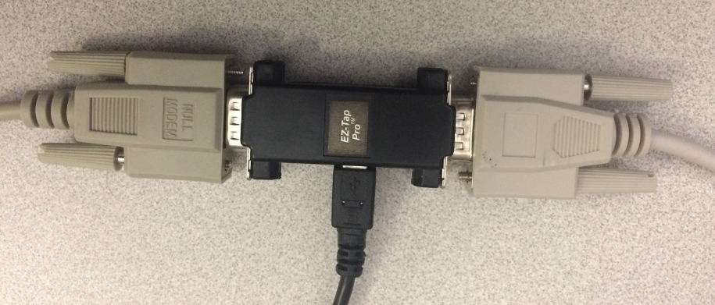 >> INTELLIO Link

## The EZView icon is displayed on the Desktop

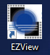

## EZView comes up in New Capture mode

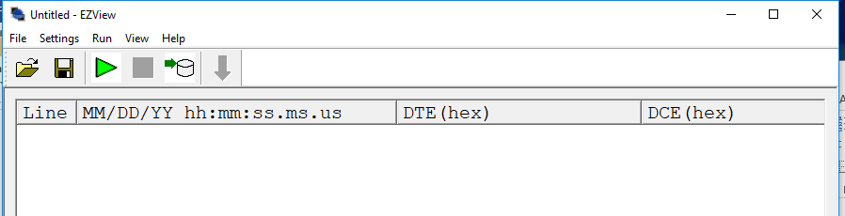

## On the EZView New Capture Mode screen, click Help > About EZView

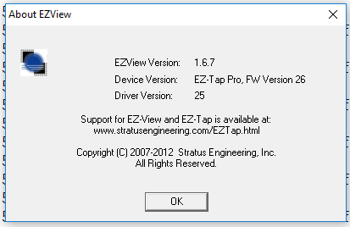

## EZView Toolbar Options - Capture and view data as text

### Highlighting a Single Line of Data

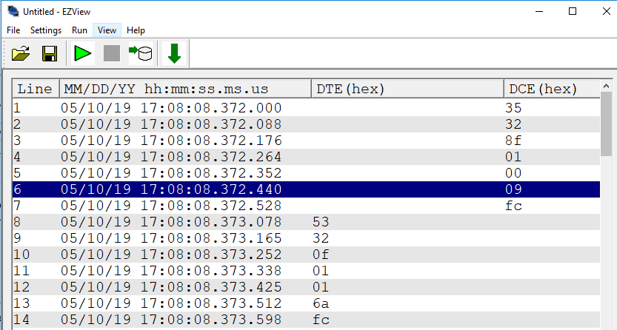

Date and Time are examples. Actual Date and Time is based on date and time of execution.

### Highlighting Multiple Lines of Data

Multiple individual lines may be highlighted by holding the Ctrl key down while clicking the lines.

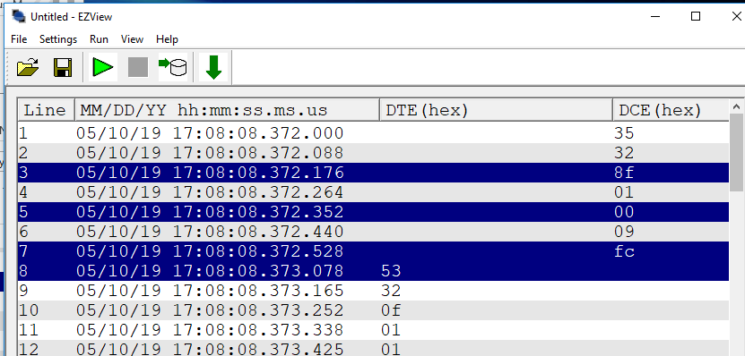

Date and Time are examples. Actual Date and Time is based on date and time of execution.

## Save EZView Data as Text

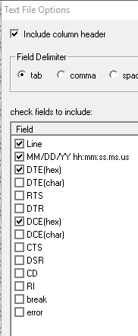

## EZView Toolbar Options - Communications Settings

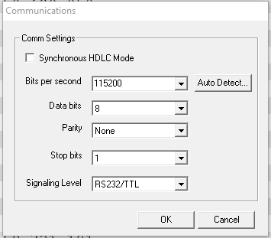

## EZView Toolbar Options – Program Options Settings)

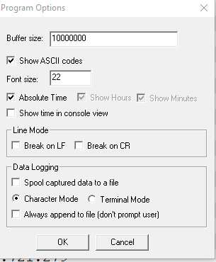

## EZView Toolbar Options – Capture Columns Settings

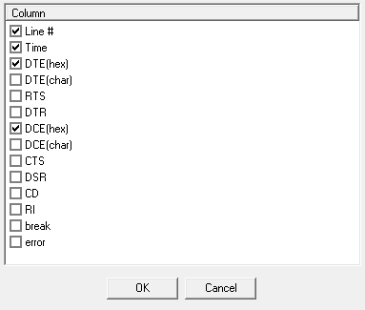

## EZView Toolbar Options – Display Mode Settings

### Single Byte Mode

Attachment 10.2 shows data displayed in Single Byte Mode.

### Line Mode

Attachment 10.1 shows data displayed in Line Mode.

## Viewing Captured EZView Data

Execution-generated captured data (Attachment 10.1) shows the following three message types:

1. Discovery Request Message DR_MSG (35 31), shown on Line 1.
2. Discovery Request Message Reply DR_MSG_RPLY (53 31), shown on Line 54.
3. Port Status Message PORT_STATUS_MSG (53 33), shown on Line 55.
4. Port Status Message Reply PORT_STATUS_MSG_RPLY (35 33), shown on Line 64.
5. Heartbeat Status Message HB_STATUS (53 32), shown on Line 69.

# Attachments

## Attached Data file EZView Data_01.txt

This data was captured by execution on the displayed Date and Times, and displayed in Line Mode.

## Attached Data file EZView Data_02.txt

This data was captured by execution on the displayed Date and Times, and displayed in Single Byte Mode.